CS 255 System Design Document Template

UML Diagrams

UML Use Case Diagram
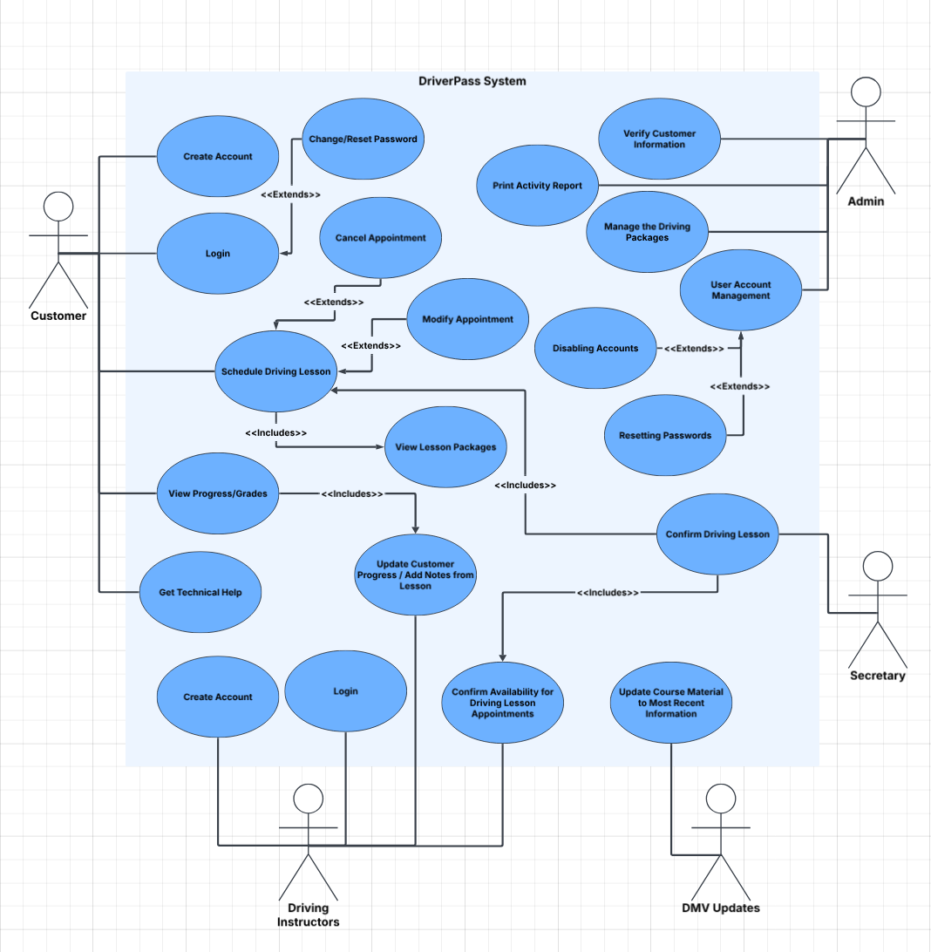

UML Activity Diagrams
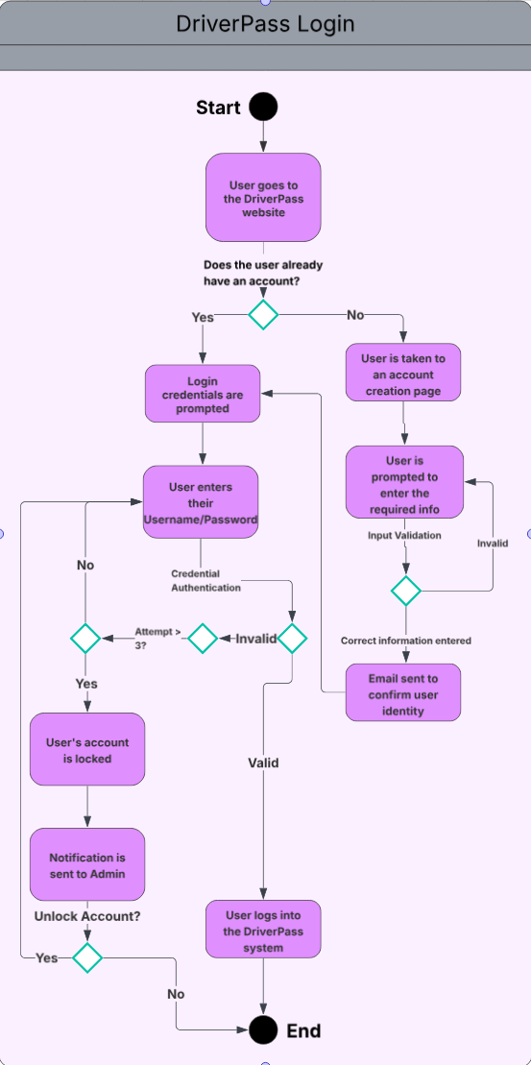
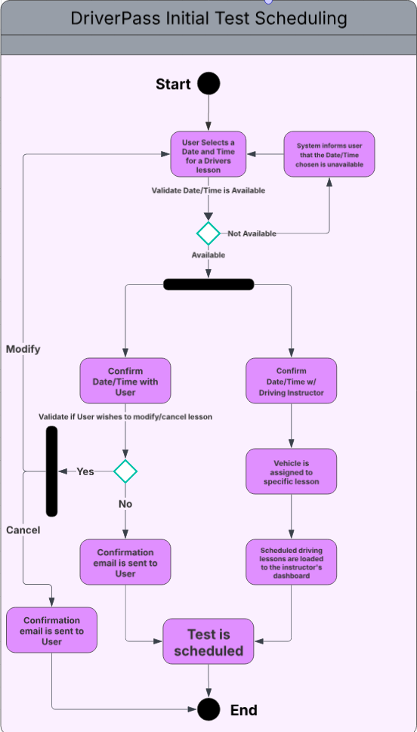

UML Sequence Diagram
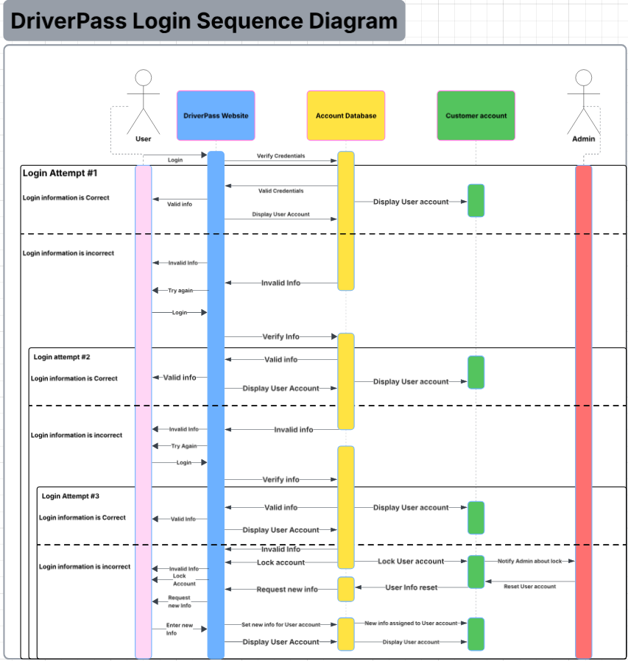

UML Class Diagram
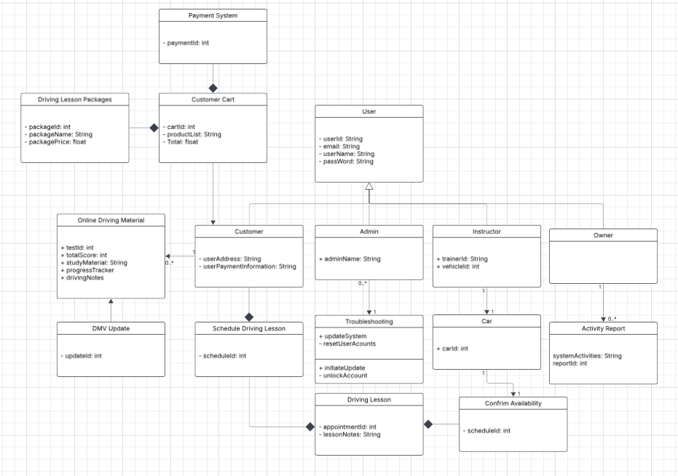

Technical Requirements
Hardware Requirements:
- A computer or mobile device
- Processors (CPUs)
- Memory (RAM)
- Adequate Storage (SSD)
- Internet connectivity
- Dedicated Servers
Software Requirements:
- Server Operating System (Windows, MAC, Linux, etc.)
- DriverPass Software
- Payment software from a 3rd party
- Cloud Storage Solution
- SSL Certificates for HTTPS
- Firewall
- Data Encryption
- Intrusion Detection System
- Multi-Factor Authentication
Tools Required for Development:
- IDEs/ code editors like VS Code, Eclipse, PyCharm, and Visual Studio
- Version Control Systems like GitHub or GitLab
- API testing tools like Postman, Insomnia, or Hoppscotch
Infrastructure Requirements:
- Physical server location or a Cloud provider
- Daily system backups
- Alerting system for detected issues

